**INTRODUCTION**

Blindness is a state of lacking the visual perception to physiological or neurological factors. The partial blindness represents the lack of integration in the growth of the optic nerve or visual center of the eye and total blindness is the full absence of the visual light perception. In this work, a simple, cheap, friendly user, smart blind guidance system is designed and implemented to improve the mobility of both blind and visually impaired people in a specific area. The proposed work includes a wearable equipment consist of spectacles to help the blind person to navigate alone safely and to avoid any obstacles that may be encountered, whether fixed or mobile, to prevent any possible accident. The main component of this system is infrared sensor which is used to scan a predetermined area around blind by emitting-reflecting waves. The reflected signals received from the barrier objects are used as input to microcontroller. The microcontroller is then used to determine the direction and distance of the objects around the blind. It also controls the peripheral components that alert the user about obstacle’s shape, material, and direction. The implemented system is cheap, fast and easy to use and an innovative affordable solution to blind and visually impaired people in third world countries. The shoe is consist of actuators and vibrators located in the front, sides and back of the shoe. With the help of a proprietary app loaded to a GPS-enabled smartphone, the user can connect with the shoe via Bluetooth and interact with the app to set a destination. The app has been designed using various accessibility options to enable completely eye-free interface use. Once the destination has been set, the smartphone calculates a route and through a series of vibrations guides the user from one point to another. The front of the shoe vibrates to indicate to go forward, the left side to turn left and so on. The shoe also includes sensors to detect obstacles such as sidewalks, staircases and manholes. The user is alerted and guided via a series of vibrations to navigate around the obstacles or to find an alternate route.

**SYSTEM OVERVIEW**

We designed and built a shoe to be worn on any leg that is connected with the android mobile application via Bluetooth. The Bluetooth module is mounted on the shoe and paired with the android mobile we aimed to create a device that could provide reliable navigation to the blind person. Our device uses ultrasonic sensors for the detection of the obstacles present in front of the blind person, it has been empirically adjusted so as to maximize the scope of the ultrasonic beam coverage, allowing it to detect ground-level obstacles also provided with the LED connected to the light emitting diode so that the person behind the blind can see him or her (blind) in the dark. The basic requirement of the device that is power supply is obtained using piezoelectric plates.

**Fundamental Concepts**

It contains the fundamental concept of the project. The fundamental concept includes the various sections such as components list along with the components description, Block diagram and analysis of the fault Detector. The chapter deals with the detailed explanation of every component of the fault detector and the study the mechanism of the flying of the unmanned aerial vehicle. It also discusses the various concepts which help to maintain the stability of the fault detector.

This chapter contains different sections which are briefly mentioned further:-

* Block diagram
* List of components
* Analysis
* **Block diagram : OLED Display**

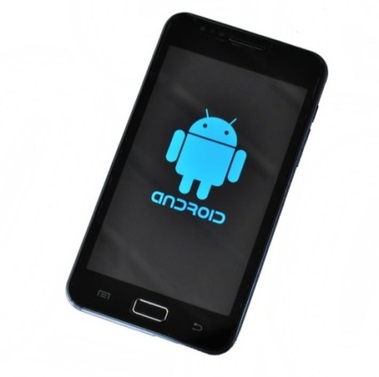

**LCD Display**

**Bluetooth Module**

**HC05**

**Clock , Reset**

**Microcontroller**

**AT mega 328**

Rx-Tx

**Power Supply Battery**

**Relay Driver**

**Relay**

**Block Diagram Explanation:**

The circuit is divided into two parts

1. Transmitter

2. Receiver

For transmitter section, the different commands signals are transmitted via RF transmitter module of 433 MHz. it has 4 pins of antenna, Vcc, Gnd, & serial data input. Antenna ,+5v &Gnd are connected to respective places and serial data input is generated from encoder IC HT12E. This encoder IC’s function is to convert parallel data into serial data address lines of encoder are grounded because they are not used. Data lines are fed with command signals since four lines are available 16 different commands can be generated. The output modulating frequency is decided by resistor connected at OSC pin of the encoder. Currently because of 1.2Mohms resistor, It is 30 KHz. The output of encoder is fed to RF transmitter module is currently Roughly 100 sq. Ft. On receiver side the data is received by RF receiver module of 433 MHz . This demodulated signal is fed to decoder for further decoding. If address send from encoder IC GND matches with decoder address then valid tone (VT) signal on decoder goes high , which indicates receives signal. The decoded by decoder is fed to uC for further control of relay. uCrequires mainly three things for operation. Which are power supply clock & reset. Power supply provided to uC is +5v & GND on pin40 &pin20 respectively. On osc pin18 &19,a crystal oscillator is connected which generates clock for program execution for reset on pin9 & 10k resistor &10k capacitor is connect which reset controller on power up.

Controller receives data from decoder & after decoding of commands it gives proper command to relay driver IC ULN2803, which amplifies signal coming from controller & controls as per controller instruction. Relay used of 12v, 400ohms SPDT type. For making motor on/off single relay is required for changing direction of motor two relays are required .direction of motor can be changed by changing the direction of supply of motor.

**Circuit Diagram:**

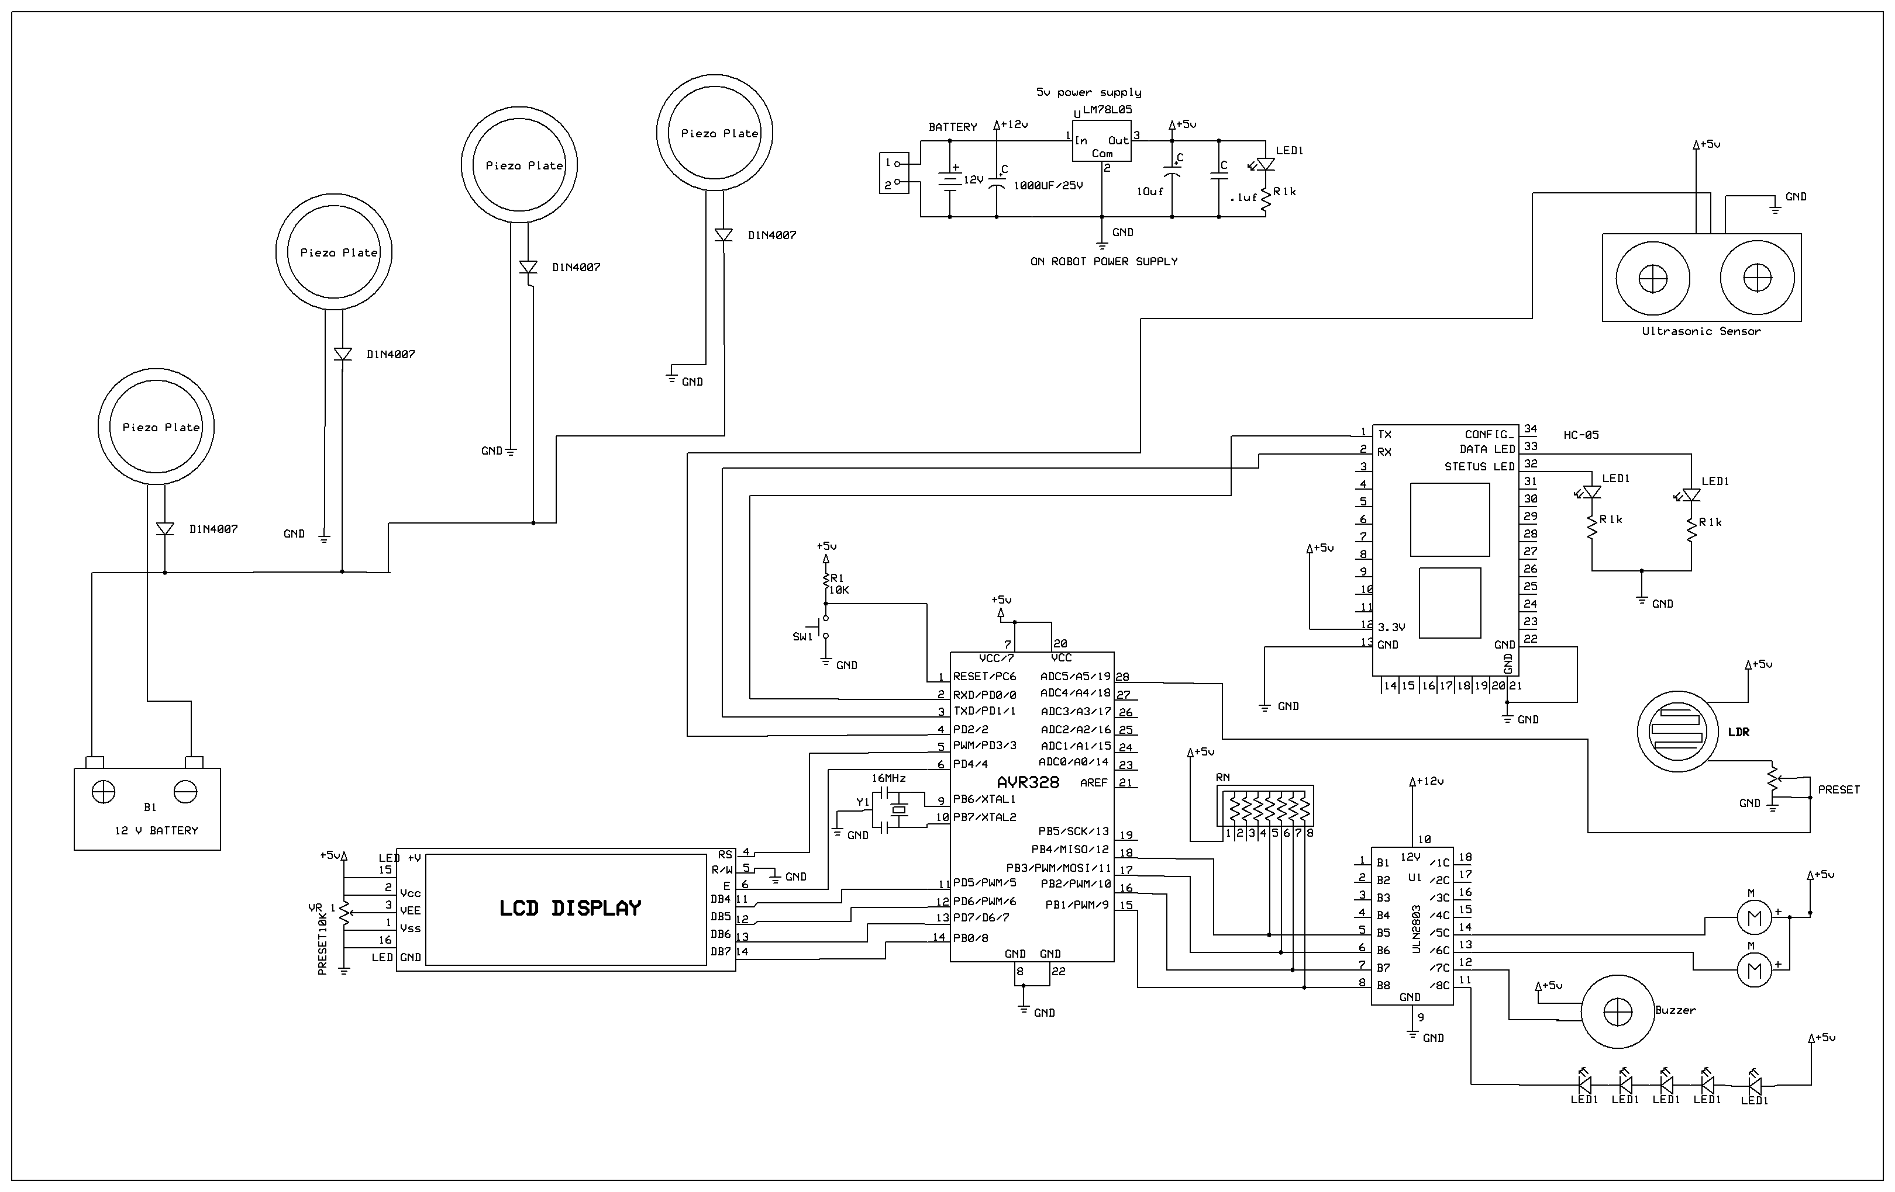

**List of Components:**

Following are the list of components to build a fault detection system:-

1. AVR 328 Microcontroller
2. Bluetooth model HC-05
3. PL-2303 USB to Serial Adapter
4. Relay
5. Relay driver
6. LCD Display
7. Buzzer
8. LM7805 Series Voltage Regulators
9. Power Supply
10. Piezo plates
11. Vibrating Motor
12. Ultrasonic sensor
13. LDR
14. **AVR 328 Microcontroller:**

The ATmega 328 is a low-power CMOS 8-bit microcontroller based on the AVR enhanced RISC architecture. By executing powerful instructions in a single clock cycle, the ATmega 328 achieves throughputs approaching 1 MIPS per MHz allowing the system designer to optimize power consumptionversus processing speed.

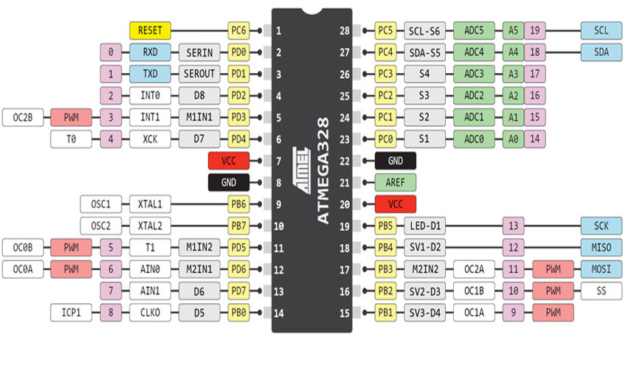

The AVR core combines a rich instruction set with 32 general purpose working registers. All the 32 registers are directly connected to the Arithmetic Logic Unit (ALU), allowing two independentregisters to be accessed in one single instruction executed in one clock cycle. The resulting architecture is more code efficient while achieving throughputs up to ten times faster than conventional CISC microcontrollers.

Features

• High Performance, Low Power AVR® 8-Bit Microcontroller

• Advanced RISC Architecture

– 131 Powerful Instructions – Most Single Clock Cycle Execution

– 32 x 8 General Purpose Working Registers

– Fully Static Operation

– Up to 20 MIPS Throughput at 20 MHz

– On-chip 2-cycle Multiplier

• High Endurance Non-volatile Memory Segments

– 4/8/16/32K Bytes of In-System Self-Programmable Flash program memory

– 256/512/512/1K Bytes EEPROM

– 512/1K/1K/2K Bytes Internal SRAM

– Write/Erase Cycles: 10,000 Flash/100,000 EEPROM

– Data retention: 20 years at 85°C/100 years at 25°C(1)

– Optional Boot Code Section with Independent Lock Bits In-System Programming by On-chip Boot Program True Read-While-Write Operation

– Programming Lock for Software Security

• Peripheral Features

– Two 8-bit Timer/Counters with Separate Prescaler and Compare Mode

– One 16-bit Timer/Counter with Separate Prescaler, Compare Mode, and Capture Mode

– Real Time Counter with Separate Oscillator

– Six PWM Channels

– 8-channel 10-bit ADC in TQFP and QFN/MLF package Temperature Measurement

– 6-channel 10-bit ADC in PDIP Package Temperature Measurement

– Programmable Serial USART

– Master/Slave SPI Serial Interface

– Byte-oriented 2-wire Serial Interface (Philips I2

– Programmable Watchdog Timer with Separate On-chip Oscillator

– On-chip Analog Comparator

– Interrupt and Wake-up on Pin Change

• Special Microcontroller Features

– Power-on Reset and Programmable Brown-out Detection

– Internal Calibrated Oscillator– External and Internal Interrupt Sources

– Six Sleep Modes: Idle, ADC Noise Reduction, Power-save, Power-down, Standby, and Extended Standby

• I/O and Packages

– 23 Programmable I/O Lines

– 28-pin PDIP, 32-lead TQFP, 28-pad QFN/MLF and 32-pad QFN/MLF

• Operating Voltage:– 1.8 - 5.5V

• Temperature Range:– -40°C to 85°C

• Speed Grade:– 0 - 4 MHz@1.8 - 5.5V, 0 - 10 MHz@2.7 - 5.5.V, 0 - 20 MHz @ 4.5 - 5.5V

• Power Consumption at 1 MHz, 1.8V, 25°C

– Active Mode: 0.2 mA

– Power-down Mode: 0.1 μA

– Power-save Mode: 0.75 μA (Including 32 kHz RTC)

**2. Bluetooth model HC-05**

HC‐05 module is an easy to use Bluetooth SPP (Serial Port Protocol) module, designed for transparent wireless serial connection setup. Serial port Bluetooth module is fully qualified Bluetooth V2.0+EDR (Enhanced Data Rate) 3Mbps Modulation with complete 2.4GHz radio transceiver and baseband. It uses CSR Bluecore 04‐External single chip Bluetooth system with CMOS technology and with AFH (Adaptive Frequency Hopping Feature). It has the footprint as small as 12.7mmx27mm. Hope it will simplify your overall design/development cycle.



**3. PL-2303 USB to Serial Adapter**

The PL-2303 USB to Serial adapter is your smart and convenient accessory for connecting RS-232 serial devices to your USB-equipped Windows host computer. It provides a bridge connection with a standard DB 9-pin male serial port connector in one end and a standard Type-A USB plug connector on the other end. You simply attach the serial device onto the serial port of the cable and plug the USB connector into your PC USB port. It allows a simple and easy way of adding serial connections to your PC without having to go thru inserting a serial card and traditional port configuration.

Finally, the PL-2303 USB to Serial adapter is a fully USB Specification compliant device and therefore supports advanced power management such as suspend and resume operations as well as remote wakeup. The PL-2303 USB Serial cable adapter is designed to work on all Windows operating systems.

**4. Relay**

A relay is an electrically operated switch. Many relays use an electromagnet to operate a switching mechanism, but other operating principles are also used. Relays find applications where it is necessary to control a circuit by a low-power signal, or where several circuits must be controlled by one signal. The first relays were used in long distance telegraph circuits, repeating the signal coming in from one circuit and re-transmitting it to another. Relays found extensive use in telephone exchanges and early computers to perform logical operations. A type of relay that can handle the high power required to directly drive an electric motor is called a contactor. Solid-state relays control power circuits with no moving parts, instead using a semiconductor device to perform switching. Relays with calibrated operating characteristics and sometimes multiple operating coils are used to protect electrical circuits from overload or faults; in modern electric power systems these functions are performed by digital instruments still called "protection relays

**5. Relay driver**

ULN2803

The eight NPN Darlington connected transistors in this family of arrays are ideally suited for interfacing between low logic level digital circuitry (such as TTL, CMOS or PMOS/NMOS) and the higher current/voltage requirements of lamps, relays, printer hammers or other similar loads for a broad range of computer, industrial, and consumer applications. All devices feature open–collector outputs and free wheeling clamp diodes for transient suppression.The ULN2803 is designed to be compatible with standard TTL families while the ULN2804 is optimized for 6 to 15 volt high level CMOS or PMOS.

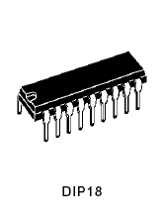

Features:

1. Eight darling tons with common emitters;

2. Output current to 500 Ma;

3. Output voltage to 50 V;

4. Integral suppression diodes;

5. Versions for all popular logic families;

6. Output can be paralleled;

7. Inputs pinned opposite outputs to simplify board layout.

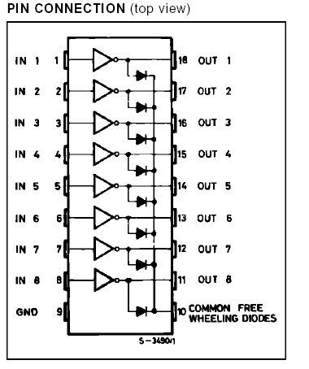

**6. LCD Display**

LCD (Liquid Crystal Display) screen is an electronic display module and find a wide range of applications. A 16x2 LCD display is very basic module and is very commonly used in various devices and circuits. These modules are preferred overSeven segments and other multi segments LEDs. The reasons being: LCDs are economical; easily programmable; have no limitation of displaying special & even custom characters (unlike in seven segments), animations and so on. A 16x2 LCD means it can display 16 characters per line and there are 2 such lines. In this LCD each character is displayed in 5x7 pixel matrix. This LCD has two registers, namely, Command and Data. The command register stores the command instructions given to the LCD. A command is an instruction given to LCD to do a predefined task like initializing it, clearing its screen, setting the cursor position, controlling display etc. The data register stores the data to be displayed on the LCD. The data is the ASCII value of the character to be displayed on the LCD. Click to learn more about internal structure of a LCD.

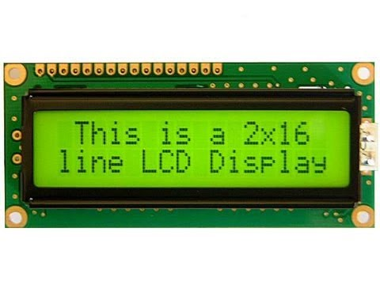

**7. Buzzer**

A buzzer or beeper is an audio signaling device, which may be mechanical, electromechanical or piezoelectric typical uses of buzzers and beepers include alarm devices, timers and confirmation of user input such as a mouse click or keystroke.

The SDC series electromagnetic buzzers have built-in oscillator circuits so that output can be produced by merely connecting to a DC power supply.

Circuitry utilizes chip-type components for significantly reducedsize and high reliability.

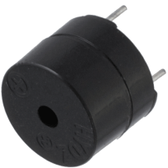

**8.LM7805 Series Voltage Regulators**

A voltage regulator is an electrical regulator designed to automatically maintain a constant voltage level. It may use an electromechanical mechanism, or passive or active electronic components. Depending on the design, it may be used to regulate one or more AC or DC voltages. With the exception of shunt regulators, all voltage regulators operate by comparing the actual output voltage to some internal fixed reference voltage. Any difference is amplified and used to control the regulation element. This forms a negative feedback servo control loop. If the output voltage is too low, the regulation element is commanded to produce a higher voltage. If the output voltage is too high, the regulation element is commanded to produce a lower voltage. In this way, the output voltage is held roughly constant.

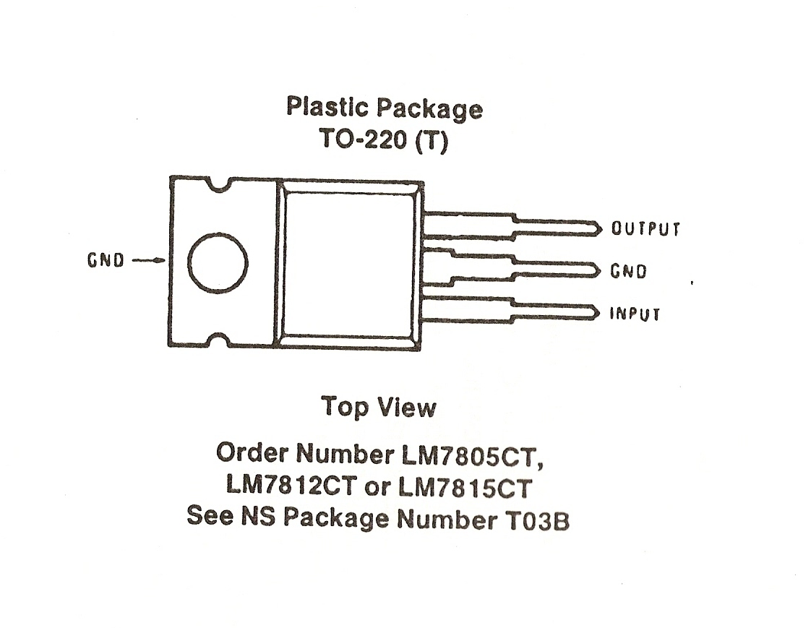

**9.Power Supply**

There are many types of power supply. Most are designed to convert high voltage AC mains electricity to a suitable low voltage supply for electronic circuits and other devices. A power supply can by broken down into a series of blocks, each of which performs a particular function.

**10. Piezo plates**

Piezoceramic components convert mechanical signals, such as force, pressure, strain or acceleration, into electrical voltage, or, vice versa, an electrical voltage into mechanical motion or oscillations. The typical resonant frequencies are between 200 kHz and 10 MHz.Piezo components, such as plates, disks or rings, are frequently used for generating ultrasonic oscillations in sensors or for high-power ultrasonic machining.

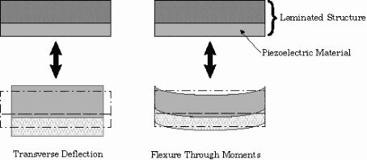

* + - Piezo electric plates are the plates which produce voltages in response to applied mechanical force.
    - It will produce power using vibrations produced during walking
    - It will produce upto 7 volts which will be regulated by voltage regulator and store in battery
    - These voltages will be used to drive the circuit.

**11. Vibrating motor**

* Vibrating motor is a normal DC motor with off centre load applied to it.
* When 1 is received transistor gets on and motor starts rotating.
* As it is provided with off centre Load it starts vibrating because of load on one side only.
* These motors are implemented on front, left and right side of the shoe.
* The vibrations of the motor will navigate the person to reach the destination.

**Concept of off centred loading**

* Off centre load is a basically a mechanical concept.
* A vibrating motor is a motor that is improperly balanced.
* There an off-centred weight attached to the motor’s rotational shaft that causes the motor to wobble.
* The amount of wobble can be changed by the amount of weight you attach, the weight’s distance from the shaft, and the speed of at which motors spins.

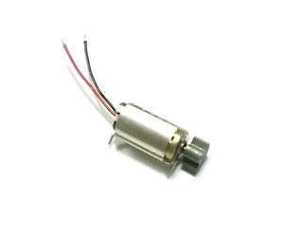

**12. Ultrasonic sensor**

Ultrasonic sensor provides an easy method of distance measurement. This sensor is perfect for any number of applications that require you to perform measurements between moving or stationary objects.

Interfacing to a microcontroller is a snap. A single I/O pin is used to trigger an ultrasonic burst (well above human hearing) and then "listen" for the echo return pulse. The sensor measures the time required for the echo return, and returns this value to the microcontroller as a variable-width pulse via the same I/O pin.

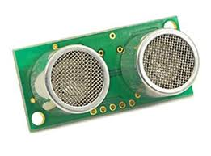

**Key Features:**

* Provides precise, non-contact distance measurements within a 2 cm to 3 m range
* Ultrasonic measurements work in any lighting condition, making this a good choice to supplement infrared object detectors
* Simple pulse in/pulse out communication requires just one I/O pin
* Burst indicator LED shows measurement in progress
* 3-pin header makes it easy to connect to a development board, directly or with an extension cable, no soldering required

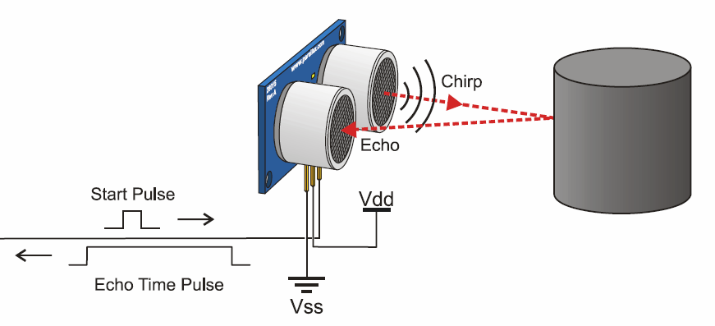

**Application Ideas**:

* Security systems
* Interactive animated exhibits
* Parking assistant systems
* Robotic navigation

**13. Light Dependent Resistor**

Light dependent resistor (LDR) whose resistance is inversely dependent on the amount of light falling cell, or simply the photocell. A typical structure for a photoresistor uses an active on it, is known by many names including the photo resistor, photoresistor, photoconductor, photoconductive semiconductor layer that is deposited on an insulating substrate. The semiconductor is normally lightly doped to enable it to have the required level of conductivity. Contacts are then placed either side of the exposed area. The photo-resistor, CdS, or LDR finds many uses as a low cost photo sensitive element and was used for many years in photographic light meters as well as in other applications such as smoke, flame and burglar detectors, card readers and lighting controls for street lamps. Providing design engineers with an economical CdS or LDR with high quality performance, Token Electronics now offers commercial grade PGM photoresistor. Designated the PGM Series, the photo resistors are available in 5mm, 12mm and 20mm sizes, the conformally epoxy or hermetical package offer high quality performance for applications that require quick response and good characteristic of spectrum. Token has been designing and manufacturing high performance light dependent resistors for decades. Our product offerings are extensive and our experience with custom photoresistor is equally extensive. Contact us with your specific needs. PGM CDS Photoresistors.

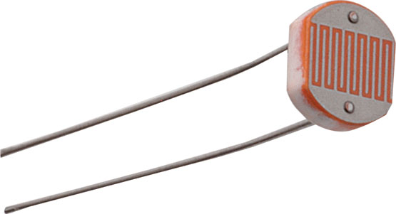

**Applications**

–Photo switch

- Photoelectric Control

- Auto Flash for Camera

– Electronic Toys, Industrial Control

**Features**

- Quick Response

- Reliable Performance

- Epoxy or hermetical package

- Good Characteristic of Spectrum

**About B4A**

* B4A stands for Basics of android.
* B4A - The simplest way to develop real-world, native Android apps.
* B4A includes all the features needed to quickly develop any type of Android app.
* B4A can run in two modes: local compilation and remote compilation.
* Local compilation mode is faster and has more options such as working with the emulator, USB debugging, unattended installations and others.
* Remote compilation mode (only available in the trial version) is simpler to get started with.

**DEVELOPMENT STAGES & PROCESS:**

The complete development of this system can be divided into the following stages:

* Problem definition stage;
* Designing block diagram;
* Implementing circuits and components;
* Developing algorithm for software;
* Writing actual code for Microcontroller;
* Compiling the code;
* Burning the hex file into microcontroller with programmer;
* Testing and Running.
  + Problem definition stage

This is the very first stage to develop any project. It actually defines the aim and the concept of the project. The aim of “Microcontroller Based Data Acquisition and Controlling System with PC interface” is to design a DAS which can be connected to any type of computer serial port giving the user flexibility of selection of desired number of channels for data acquisition with least complexity and cost.

* + Designing block diagram

At this stage we have categorized the whole system into different individual modules. These modules (block diagrams) will be helpful in understanding the concept and working of the integrated system. It also simplifies the entire debugging and testing process.

* + Implementing circuits and components

This is the actual implementation of circuit of each block. At this stage we have actually designed each block separately and finally integrated them into the complete working system.

* + Developing algorithm for software

To get the logical flow of the software, the development of algorithm is having a prominent role. So that we have analyzed the complete system and organized the algorithm in such a manner that one can understand the complete working of the software.

* + writing actual code for Microcontroller

After the development of the algorithm and flowchart we have actually translated them in C language for Atmel 89C51 Microcontroller so that it can understand the instructions and run as per our requirement. The instructions are in ANSII C Language.

* + Compiling the code

The code is implemented on the computer for which we have used Keil pre-installed on PC. The Keil is a Computer Aided Program to simulate the working of Microcontroller in real time without burning the software into actual IC. We simulated and compiled our program for error checking. After removing of several compiling errors the program was converted into machine language i.e. Intel hex format.

* + Burning the hex file into microcontroller with Programmer

In this stage the compiled hex format file was downloaded or burned into Atmel AT89C51 flash Microcontroller. This was done with the help of FP-8903 Programmer for Atmel microcontrollers designed by Oriole Electronics Pvt.

* + Testing and Running

This time we tested our project for actual working, after loading the software into the microcontroller. Any errors found were removed successfully. This is the last and final stage of development of our project.

**Program:**

**#include <LiquidCrystal.h>**

**#include <SoftwareSerial.h>**

**LiquidCrystallcd(19,4,5,6,7,8);**

**#define rxPin 2**

**#define txPin 3**

**SoftwareSerialmySerial= SoftwareSerial(rxPin, txPin);**

**intdistValue = 0;**

**intlValue = 0;**

**intinByte;**

**void setup()**

**{ Serial.begin(9600);**

**lcd.begin(16, 2);**

**lcd.print(" ");**

**lcd.setCursor(0,1);**

**lcd.print(" ");**

**delay(2000);**

**lcd.clear();**

**lcd.print(" ");**

**lcd.setCursor(0,1);**

**lcd.print(" ");**

**delay(2000);**

**lcd.clear();**

**lcd.print("Guided By:Prof.");**

**lcd.setCursor(0,1);**

**lcd.print(" ");**

**delay(2000);**

**lcd.clear();**

**pinMode(9, OUTPUT);**

**pinMode(10, OUTPUT);**

**pinMode(11, OUTPUT);**

**pinMode(12, OUTPUT);**

**pinMode(13, OUTPUT);**

**mySerial.begin(9600);**

**delay(500);**

**}**

**void loop()**

**{ while (mySerial.available() > 0)**

**{**

**inByte = mySerial.read();**

**lcd.setCursor(0,1);**

**lcd.print("Data:");**

**lcd.print(inByte);**

**lcd.print(" ");**

**if(inByte == '1')**

**{**

**digitalWrite(10,HIGH);**

**delay(250);**

**digitalWrite(10,LOW);**

**}**

**if(inByte == '2')**

**{**

**digitalWrite(11,HIGH);**

**delay(250);**

**digitalWrite(11,LOW);**

**}**

**if(inByte == '3')**

**{**

**digitalWrite(12,HIGH);**

**delay(250);**

**digitalWrite(12,LOW);**

**}**

**}**

**while (Serial.available() > 0)**

**{**

**distValue = Serial.parseInt(); // look for the next valid integer in the incoming serial stream:**

**if (Serial.read() == '\n')**

**{**

**distValue = constrain(distValue, 0, 255);**

**}**

**}**

**lValue = analogRead(A0);**

**lcd.setCursor(0,0);**

**lcd.print("Dist:");**

**lcd.print(distValue);**

**lcd.print(" ");**

**lcd.setCursor(9,0);**

**lcd.print("L:");**

**lcd.print(lValue);**

**lcd.print(" ");**

**if(lValue<200)**

**{**

**digitalWrite(9,HIGH);**

**}**

**else**

**{**

**digitalWrite(9,LOW);**

**}**

**if((distValue<100)&&(distValue>50))**

**{**

**digitalWrite(13,HIGH);**

**delay(250);**

**digitalWrite(13,LOW);**

**}**

**if(distValue<50)**

**{**

**digitalWrite(13,HIGH);**

**delay(750);**

**digitalWrite(13,LOW);**

**}**

**//inByte=0;**

**delay(100);**

**}**

**B4A Code:**

#Region Module Attributes

#FullScreen: False

#IncludeTitle: False

#ApplicationLabel: Smart Shoes

#VersionCode: 1

#VersionName: 1

#SupportedOrientations: portrait

#CanInstallToExternalStorage: True

#End Region

'Activity module

Sub Process_Globals

DimSerial1AsSerial

DimTextReader1AsTextReader

DimTextWriter1AsTextWriter

DimconnectedAsBoolean

DimGPS1AsGPS

DimsensorAsBoolean

DimcommandAsString

DimsmsdataAsString

DimVibrateAsPhoneVibrate' For phone vibration

DimSmsAsPhoneSms

DimTTS1AsTTS

DimVRAsVoiceRecognition

DimdestAsBoolean

End Sub

Sub Globals

DimtxtStreetAsEditText

DimtxtCityAsEditText

DimtxtZipAsEditText

DimButton1AsButton

DimButton2AsButton

DimButton3AsButton

DimButton4AsButton

DimButton5AsButton

DimlblLonAsLabel

DimlblLatAsLabel

End Sub

Sub Activity_Create(FirstTimeAsBoolean)

IfFirstTimeThen

Serial1.Initialize("Serial1")

GPS1.Initialize("GPS")

VR.Initialize("VR")

TTS1.Initialize("TTS1")

EndIf

Activity.LoadLayout("welcome")

IfVR.IsSupportedThen

ToastMessageShow("Voice recognition is supported.", False)

Else

ToastMessageShow("Voice recognition is not supported.", True)

EndIf

DimPairedDevicesAsMap

PairedDevices = Serial1.GetPairedDevices

Dim l AsList

l.Initialize

Fori = 0ToPairedDevices.Size - 1

l.Add(PairedDevices.GetKeyAt(i))

Next

Dim res AsInt

res = InputList(l, "Choose device", -1) 'show list with paired devices

If res <>DialogResponse.CANCELThen

Serial1.Connect(PairedDevices.Get(l.Get(res))) 'convert the name to mac address

EndIf

End Sub

Sub Serial1_Connected (Success AsBoolean)

If Success Then

ToastMessageShow("Connected successfully", False)

TextReader1.Initialize(Serial1.InputStream)

TextWriter1.Initialize(Serial1.OutputStream)

connected = True

Else

connected = False

Msgbox(LastException.Message, "Error connecting.")

EndIf

End Sub

Sub Activity_Resume

IfSerial1.IsEnabled = FalseThen

Msgbox("Please enable Bluetooth.", "")

Else

Serial1.Listen 'listen for incoming connections

EndIf

IfGPS1.GPSEnabled = FalseThen

ToastMessageShow("Please enable the GPS device.", True)

StartActivity(GPS1.LocationSettingsIntent) 'Will open the relevant settings screen.

Else

GPS1.Start(0, 0) 'Listen to GPS with no filters.

EndIf

sensor=True

End Sub

Sub Button1_Click

smsdata="I am in need of urgent help.My location is "&lblLat.Text&" "&lblLon.text

Sms.Send("09867964970",smsdata)

End Sub

Sub ImageView1_Click

Activity.LoadLayout("names")

End Sub

Sub Panel1_Click

Activity.LoadLayout("sensor")

sensor=True

End Sub

Sub GPS_LocationChanged (Location1 AsLocation)

Ifsensor=TrueThen

lblLat.Text = "Lat = "&Location1.ConvertToMinutes(Location1.Latitude)

lblLon.Text = "Lon = "&Location1.ConvertToMinutes(Location1.Longitude)

EndIf

End Sub

Sub GPS_UserEnabled (Enabled AsBoolean)

ToastMessageShow("GPS device enabled = "& Enabled, True)

End Sub

Sub btnNavigate_Click

DimsAdressAsString

sAdress = txtStreet.Text&","&txtCity.Text&","&txtZip.Text

NavigateToStreetAdress(sAdress)

End Sub

Sub NavigateToStreetAdress (sAdressAsString)

'google place, just show map

DimmapIntentAsIntent

DimgeoURIAsString

'geoURI="google.navigation:q=" & Latitude & "," & Longitude

geoURI="google.navigation:q="&sAdress

mapIntent.Initialize(mapIntent.ACTION_VIEW,geoURI)

mapIntent.SetComponent("googlemaps")

StartActivity(mapIntent)

End Sub

Sub VR_Result (Success AsBoolean, Texts AsList)

If Success = TrueThen

ToastMessageShow(Texts.Get(0), True)

TTS1.Speak(Texts.Get(0), True)

command = Texts.Get(0)

dest=True

EndIf

Ifcommand = "home"Then

txtStreet.Text="sector 48"

txtCity.Text="sea woods"

txtZip.Text="400706"

dest=True

EndIf

Ifcommand = "college"Then

txtStreet.Text="sector 5"

txtCity.Text="kharghar"

txtZip.Text="410210"

dest=True

EndIf

Ifcommand = "station"Then

txtStreet.Text="kharghar Station"

txtCity.Text="kharghar "

txtZip.Text="410210"

dest=True

EndIf

Ifcommand = "navigate"Then

dest=False

btnNavigate_Click

EndIf

Ifdest = TrueThen

VR.Listen'calls the voice recognition external activity

EndIf

End Sub

Sub Button2_Click

dest=True

VR.Prompt = "select destination"

TTS1.Speak("select destination", False)

VR.Listen

End Sub

Sub Button3_Click

IfconnectedThen

TextWriter1.WriteLine("1")

TextWriter1.Flush

EndIf

End Sub

Sub Button4_Click

IfconnectedThen

TextWriter1.WriteLine("2")

TextWriter1.Flush

EndIf

End Sub

Sub Button5_Click

IfconnectedThen

TextWriter1.WriteLine("3")

TextWriter1.Flush

EndIf

End Sub

**RESULT:**

Thefinal outcome of our project and the activities for making the device, problems faced and their solutions.

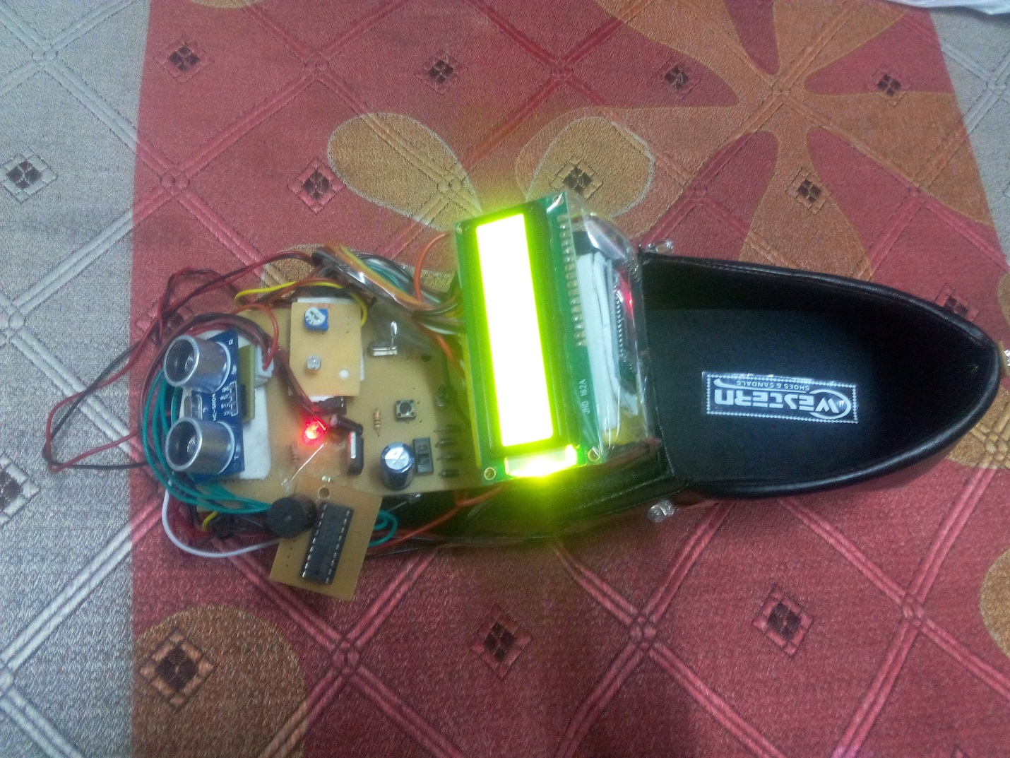

**FEATURES OF SMART SHOE:**

1) Obstacle detection : Detect nearby obstacles that are ahead, at head level, and at ground level and indicate their approximate locations and distances without causing sensory overload.

2) Warn of impeding obstacles: Reliably locate and warn of impeding potholes, low obstacles, step-downs and step-ups.

3) Guidance around obstacles: Guide the traveler around impeding obstacles.

4) Ergonomically designed: Offer voice and/or tactile feedback of traveller’s present location. Capable of voice input operation and/or have tactually distinct push buttons.

5 )Way finding: Able to monitor the traveler’s present location and indicate the direction toward the destination.

6) Route recall :Be able to remember a previous rout and warn of changes in the environment due to construction or other blockages.

7 )Operational flexibility: Reliably function in a variety of settings; i.e., outdoors, indoors, stairways, elevators, and cluttered open spaces.

8) User friendliness: Be portable, rigged, fail-safe, and affordable for a blind user.

9 )Cosmesis: Be perceived by potential users as cosmetically acceptable and comfortable to use in terms of size, styling, obtrusiveness, and attractiveness.

10) Good battery life :Have rechargeable batteries that can last for at least 6 hours per charge.

**LIMITATIONS:**

It will navigate through the pre-specified routes only.

**CONCLUSIONS**

A prototype, smart rehabilitative shoes has been designed and developed to facilitate safe navigation and mobility of blind individuals. The system has been designed for individuals with visual loss requiring enhancement and substitution aids. The rehabilitative system developed in this study is regarded as a step-forward towards the advancements in Electronic Travel Aids, and should contribute to the betterment of, and add value to, the life of individuals with vision loss.

**REFERENCE**

1.Basic Electronics – B.Ram

2.Digital Electronics – R.P.Jain

3.E. Foulke, “The perceptual basis for mobility”, AFB Research Bulletin, Vol. 23, pp. 1-8, 1971.

4. A. Colenbrander, “Visual standards: aspects and ranges of vision loss,” Report prepared for the International Council of Ophthalmology at the 29th International Congress of Ophthalmology, Sydney, Australia, 33 pp., 2002.

5. Anonymous, “Visual impairment and blindness,” Fact Sheet No. 282. World Health Organization, Geneva, Switzerland [Online]. Available: http://www.who.int/mediacentre/factsheets/fs282/en

6. Z.O. Abu-Faraj, D.M. Abou Rjeily, R.W. Bou Nasreddine, M.A. Andari, H.H. Taok. “A prototype retinal prosthesis for visual stimulation.” In: Proceedings of the 29th Annual International Conference of the IEEE Engineering in Medicine and Biology Society, pp. 5774-5777, August 23-26, 2007, Lyon, France.



